DOE Finalizes Environmental Report and Partnership with Marshall County Students

PADUCAH, KY – Marshall County High School (MCHS) AP environmental science class students completed their second year of a partnership with the Department of Energy (DOE) in May 2015. The students developed a summary of the DOE’s 2012 Annual Site Environmental Report (ASER) for the Paducah Gaseous Diffusion Plant (PGDP) Site. The 2012 ASER is a technical DOE-prepared document that summarizes the results from the various environmental monitoring programs and activities carried out during the year. The results in the ASER are based on thousands of environmental samples collected at or near the DOE Site.

In developing the summary of the 2012 ASER, the students’ goal was to learn about the operations, environmental impacts, and cleanup activities at the PGDP and communicate their new knowledge to the public. The students began the project in October 2014 with a DOE Environmental Management program presentation and guided tour of PGDP. This was followed by subject matter expert technical presentations on various aspects of the PGDP’s enrichment-operations history, environmental contamination, contaminant types, and the sampling and analysis of environmental samples. The student summary of the 2012 ASER was distributed to DOE and participants in December 2015 and is published on the Kentucky Research Consortium for Energy and Environment website, www.ukrcee.org. (http://www.ukrcee.org/Marshall/documents/MCHS_Student_ASER_2012_FINAL.pdf)

At a project-completion celebration, Jennifer Woodard, Paducah DOE Site Lead, thanked the students for their work and encouraged them to take advantage of future DOE and contractor internships available at the DOE site. Woodard added, “DOE looks forward to participating with students again.”

“This experience has been eye opening for the students,” said Tina Marshall, MCHS Environmental Science teacher. “They most enjoyed learning about the DOE operations and working outdoors.”

MCHS student Samantha Ruley said the students now have a better understanding of the DOE mission at the Paducah site. The students also enjoyed learning about the varied species of animals in the West Kentucky Wildlife Management Area adjacent to the DOE’s Paducah site.

The MCHS student ASER project is sponsored by DOE through a financial assistance grant with the Kentucky Research Consortium for Energy and the Environment (KRCEE) at the University of Kentucky Center for Applied Energy Research. The KRCEE was created in September 2003 to support DOE’s environmental restoration efforts at the Paducah Site and surrounding areas.
The DOE Paducah Site office partners with many school and educational events in the region encouraging students to study science, technology, engineering, and math (STEM). On February 19, DOE will team with the University of Kentucky and the Paducah Area Chamber of Commerce’s Business Education Partnership to host the annual Paducah Regional Science Bowl high school teams. The Science Bowl will be held at the UK College of Engineering Paducah Campus.
Like a sporting event, Science Bowl participants compete in a round robin format followed by a single or double elimination tournament in which teams of students compete in a fast paced “Jeopardy®” style question and answer format. The winning team will be invited to compete in the 2016 National Science Bowl® final. This national event will be held from April 28 through May 2, 2016, in Washington, DC.

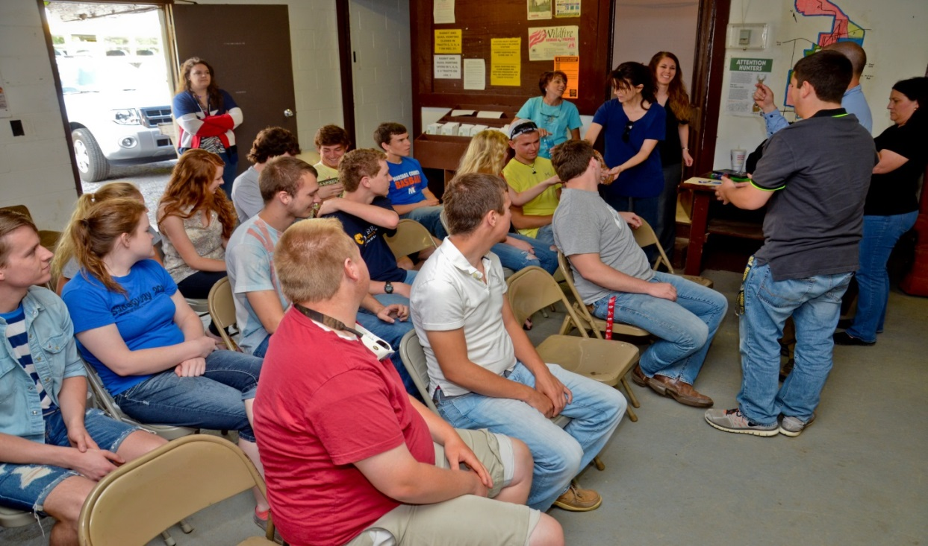

Marshall County High School students gathered at the West Kentucky Wildlife Management Area to learn about the environment around the Paducah Gaseous Diffusion Plant.

Two students examine a snake as part of learning about wetlands and other habitats at the Western Kentucky Wildlife Management Area and the species that inhabit them.
Photos compliments of KRCEE

